Format to be followed:-
— — — — — — — — — —
Question Number
(Image)
(Question Text to be displayed)
Some Description for others if required
Answer
— — — — — — — — — —

R0 Question 1: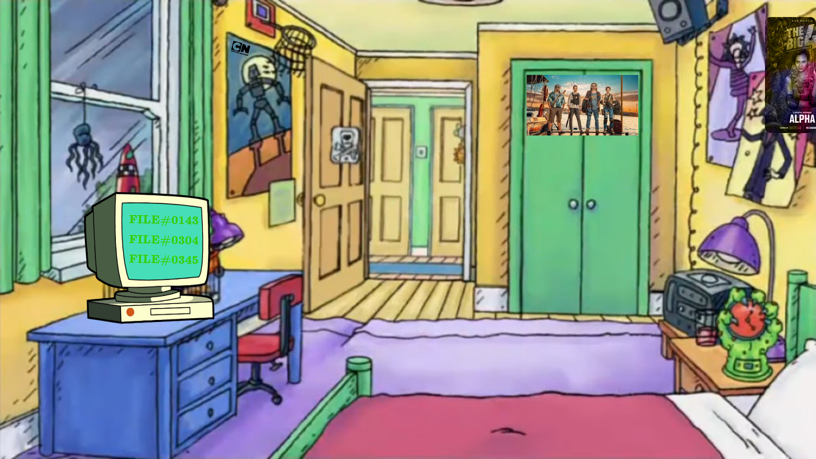

We need to include following links
File#0143: https://youtu.be/AvGvKjqZfew?si=JsgCjF-i8WAURGLa
File#0304:
https://youtu.be/5M0SQu71VA0?si=SvQfr0yRSZNd-Qco
File#0345:
https://youtu.be/zMYy67B0gDA?si=Xlaqy8dUqBsO9SqU

Answer: Dragon Ball
3 hints are included.
- Cartoon Network Logo- dragon ball used to aire on CN in hindi.
- The Big 4- if you search the big 4 anime you get Dragon Ball.
- The file numbers are actually timestamps for the respective youtube videos and you will get the following image
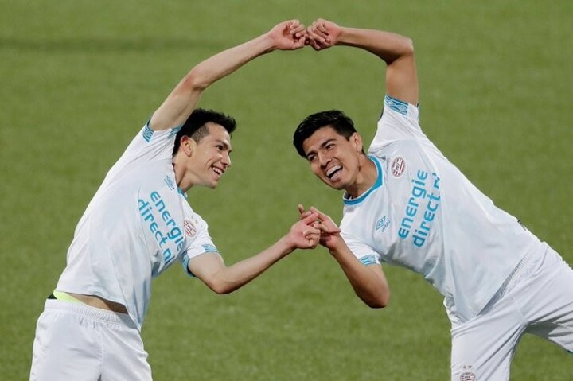
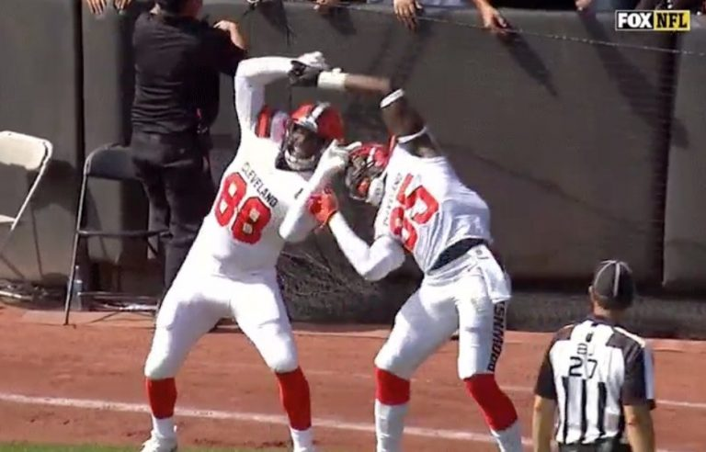

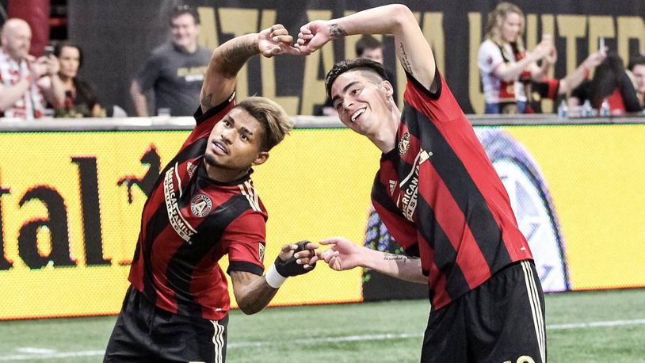
Which is a direct reference to DragonBall

R1 Question 2:
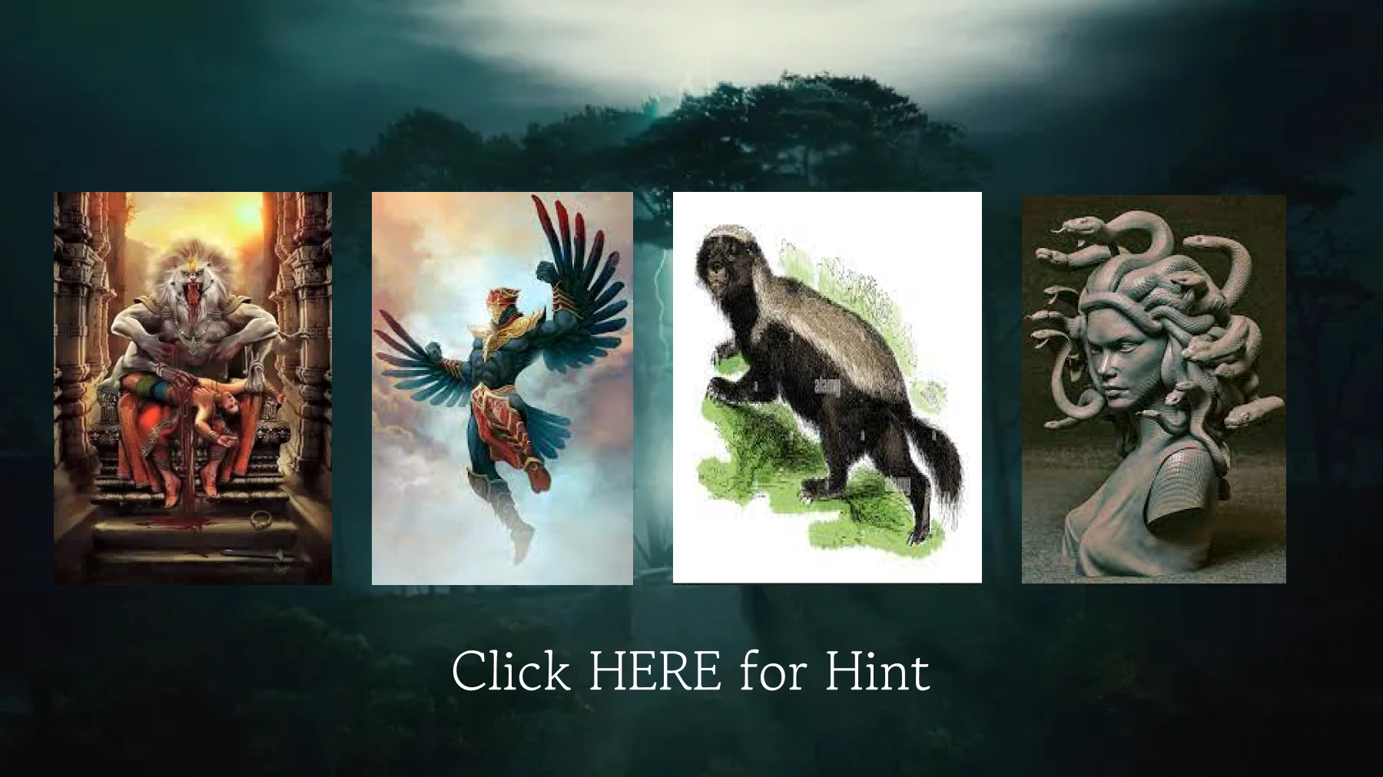
And upon clicking 'Here' it will direct you to a textbook which would look like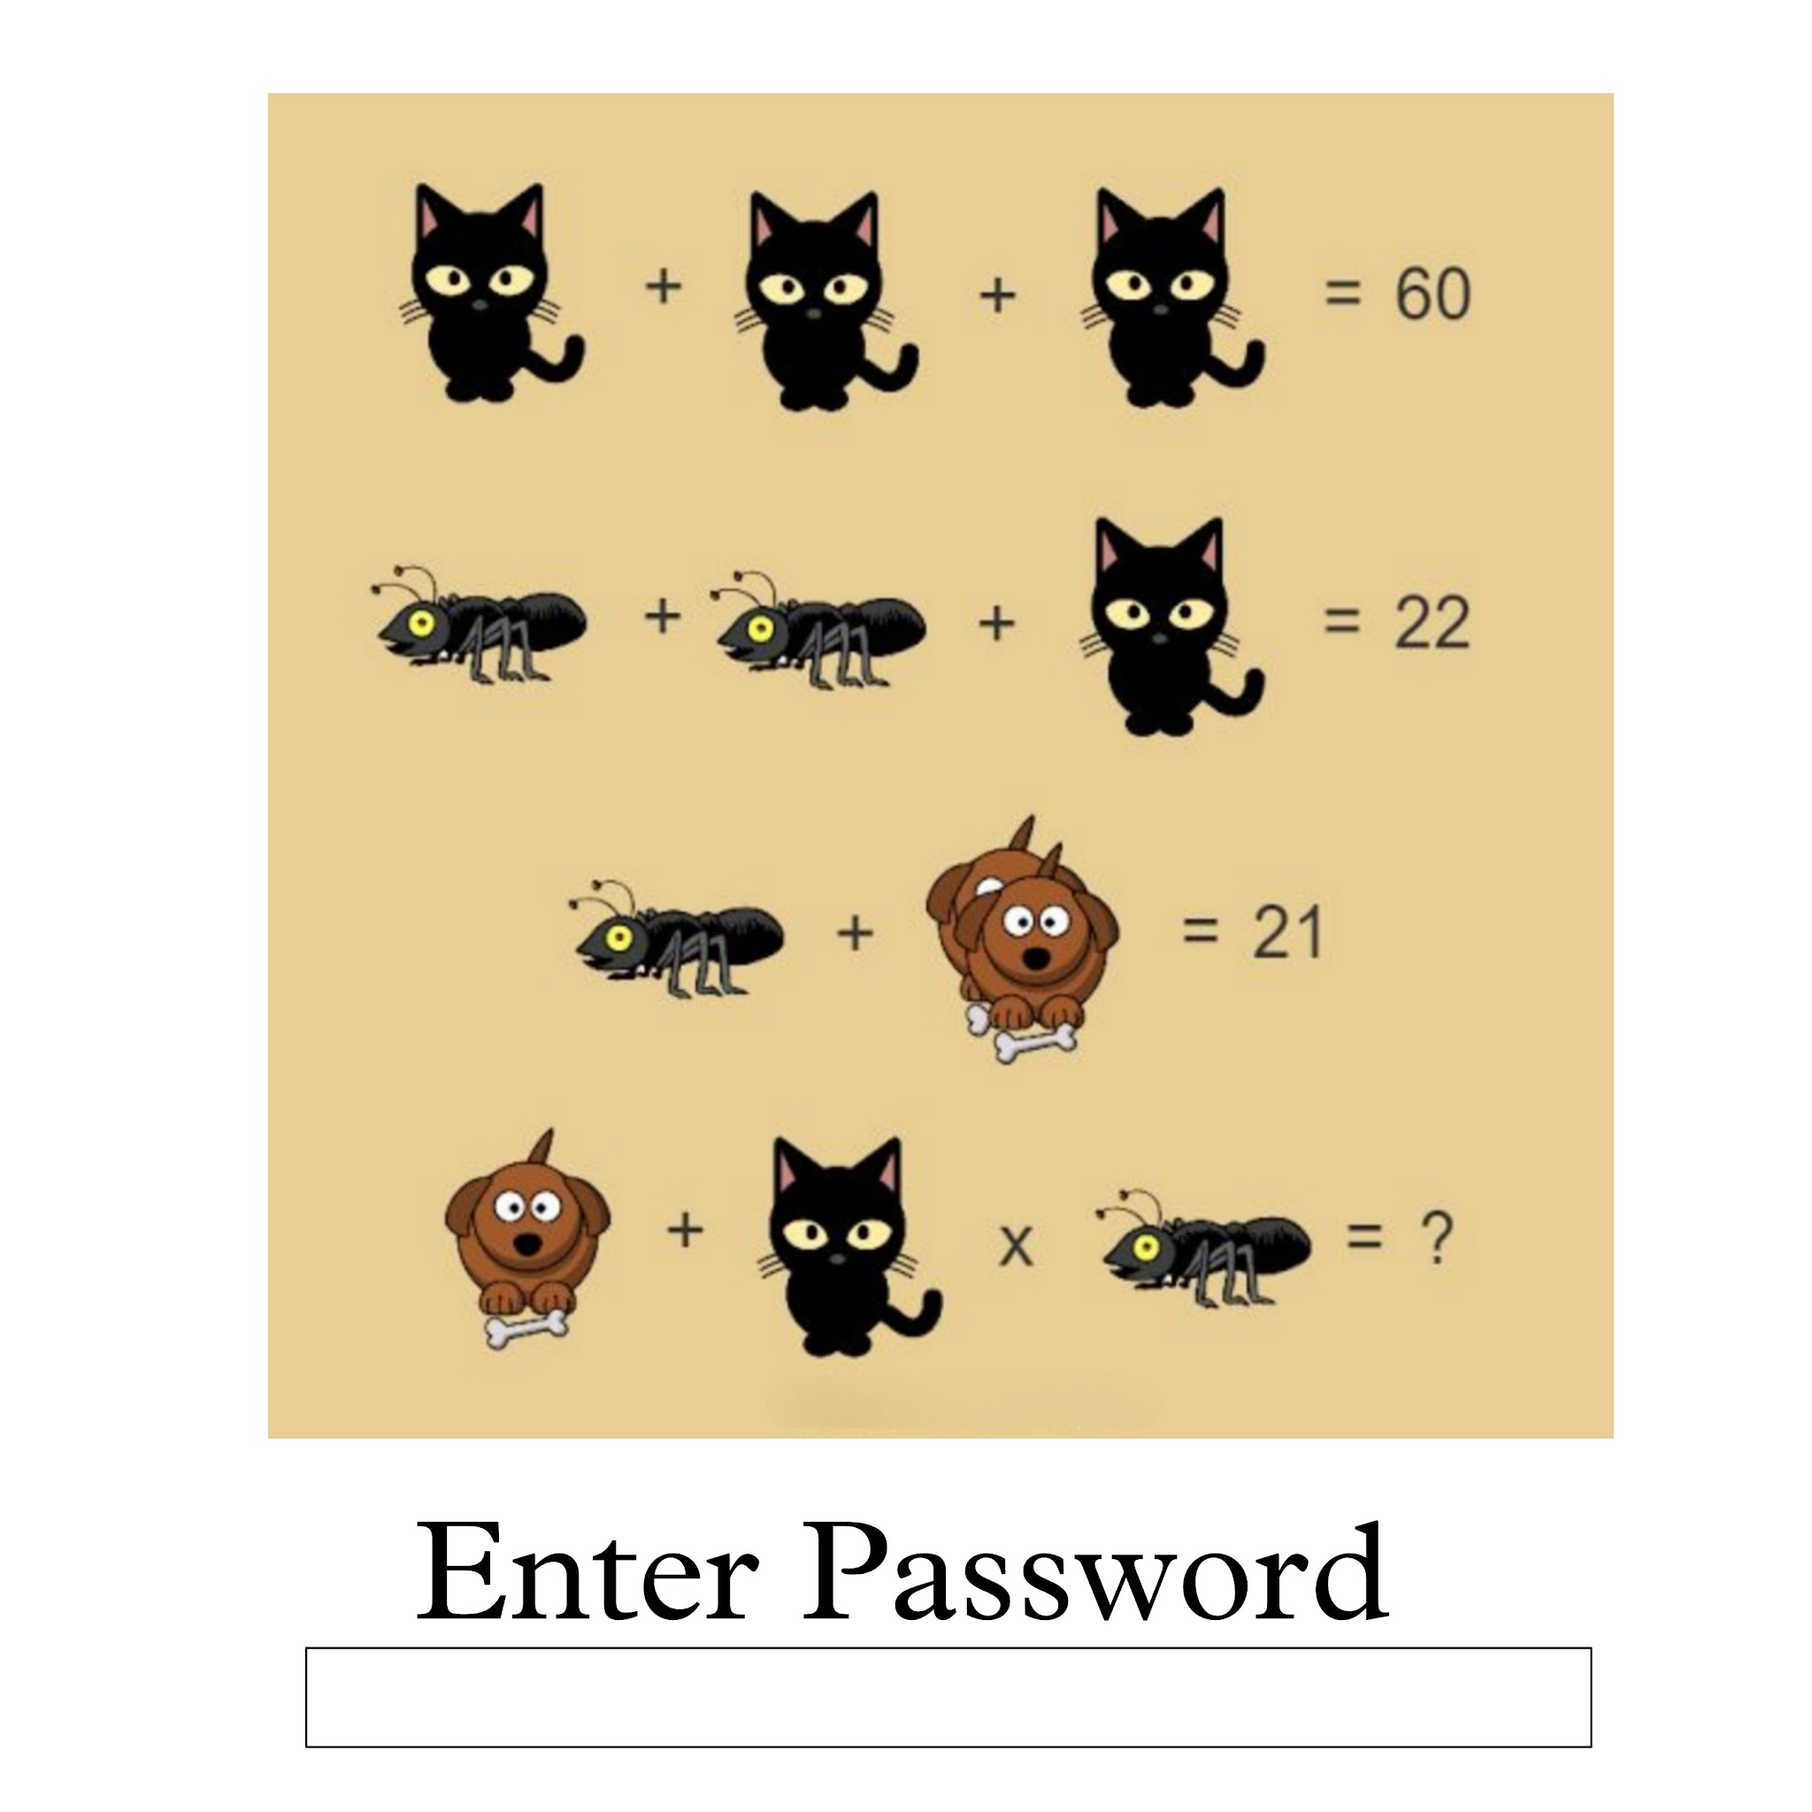
Here you have to enter 'Password' to move forward, else it will say error. (people will go on solving the mathematics) Then it will say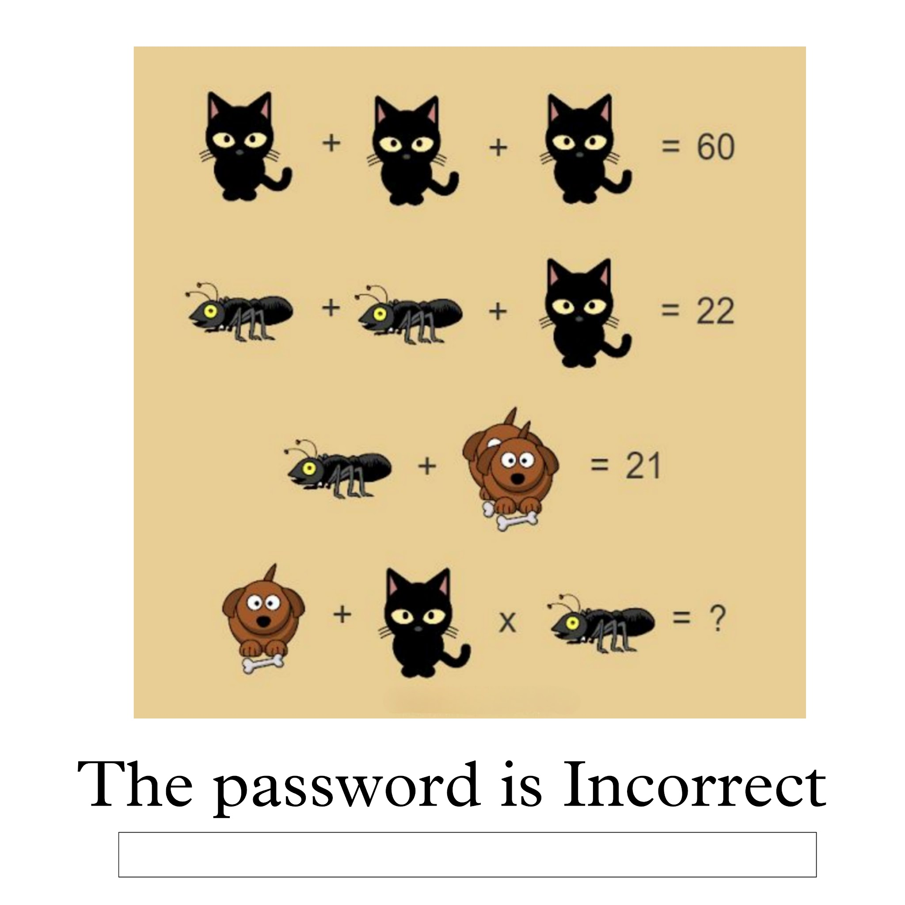
Here you have to enter 'Incorrect' to move forward else it will day error. Then it will show 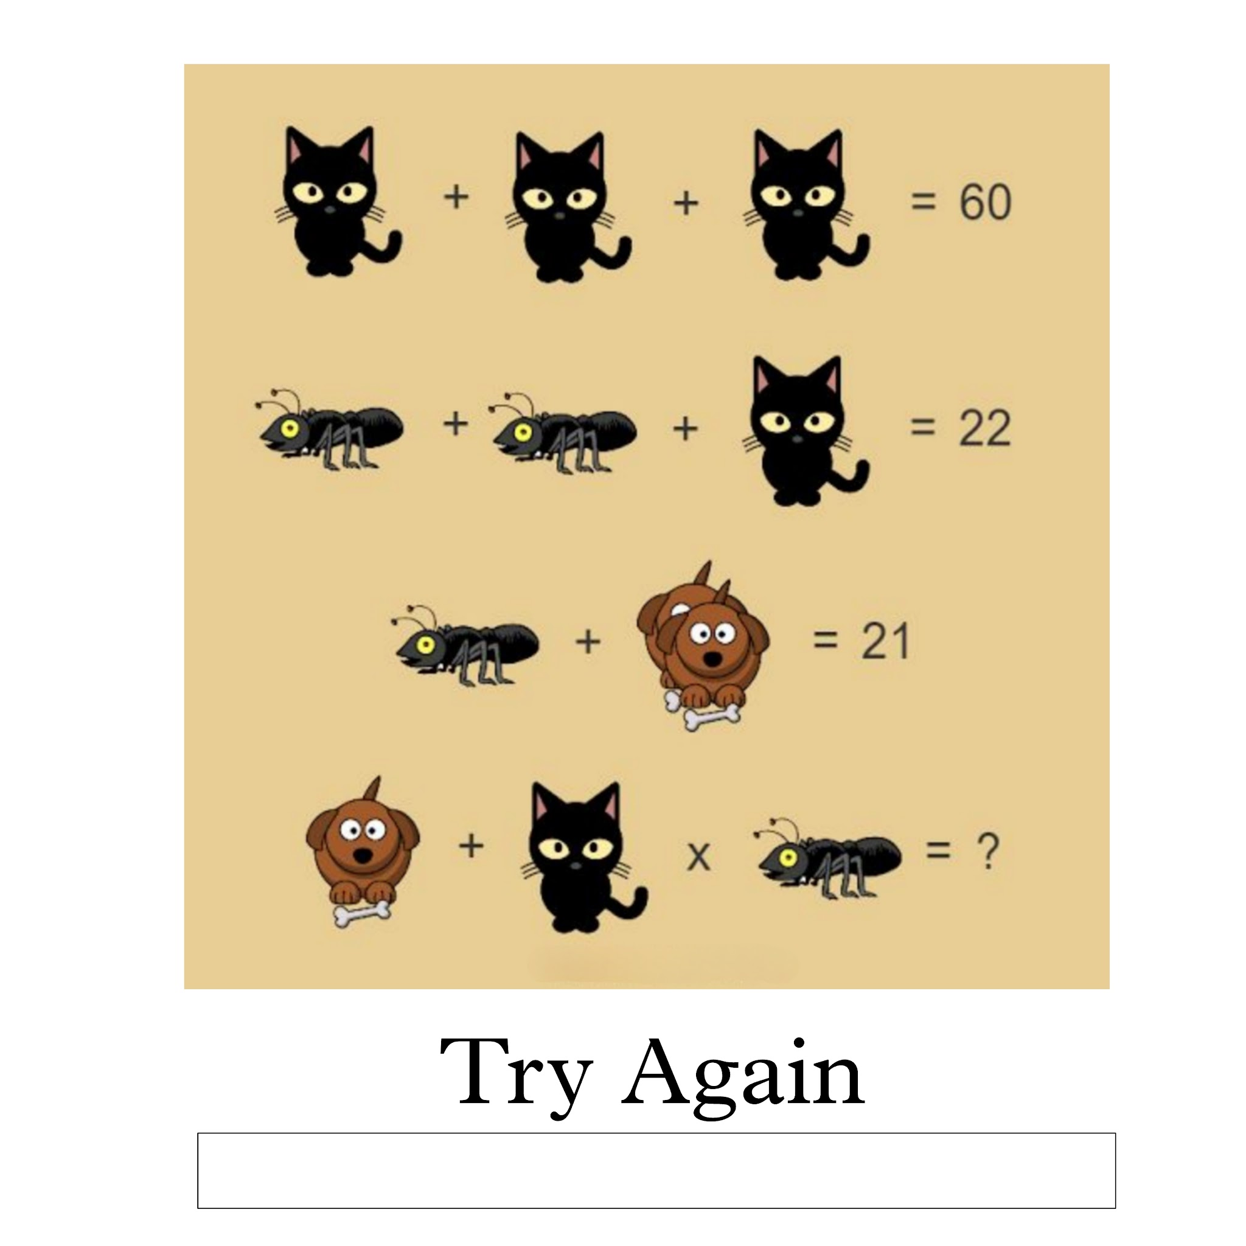
Here you have to enter 'Again' then it will direct you to a link of an audio file which will play the Harry Potter background tune.
**Need
help making such an interface of textbox**
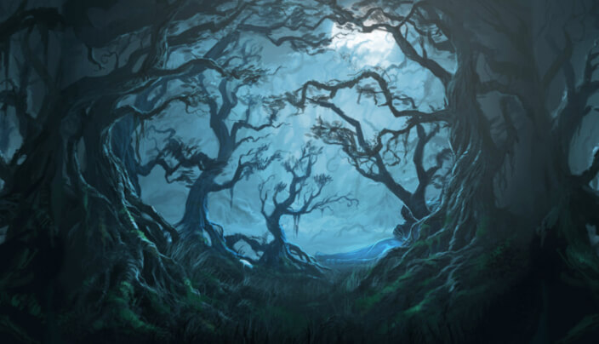
Hints:
- The background image is of forbidden forest from the Harry Potter series.
- All these animals are the logo of four houses of Hogwarts.

Updating Options:-
- Grid
- Odd one out
- Puzzle lead to chess moves

Answer: ForbiddenForest

R1 Question 3:
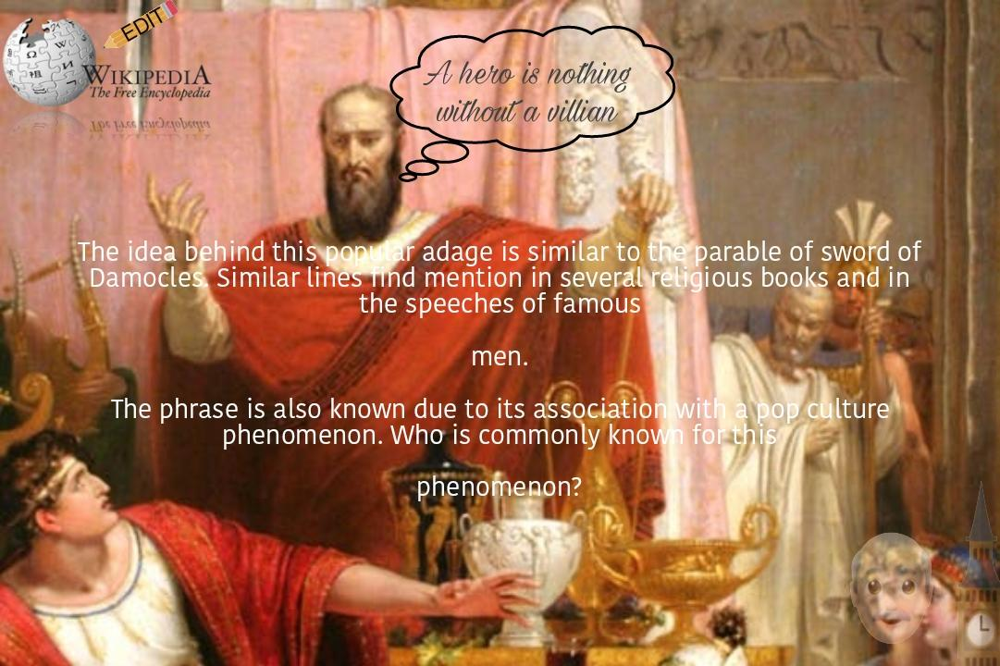
The phrase is 'With great power comes great responsibilities.'
Hints:
- Is famous in current Pop-culture.
- The similar phrase appears when you try to edit Wikipedia.
- There is also a fient emoji of 'Uncle' and 'Big Ben' which leads to Uncle Ben who said this to spiderman.
- If you get to the phrase then simply searching the phrase will Give spiderman.
Addition:- X is nothing without a ___ (dialog box from his mouth)
Answer:- Bonesaw

R0 Question 4:
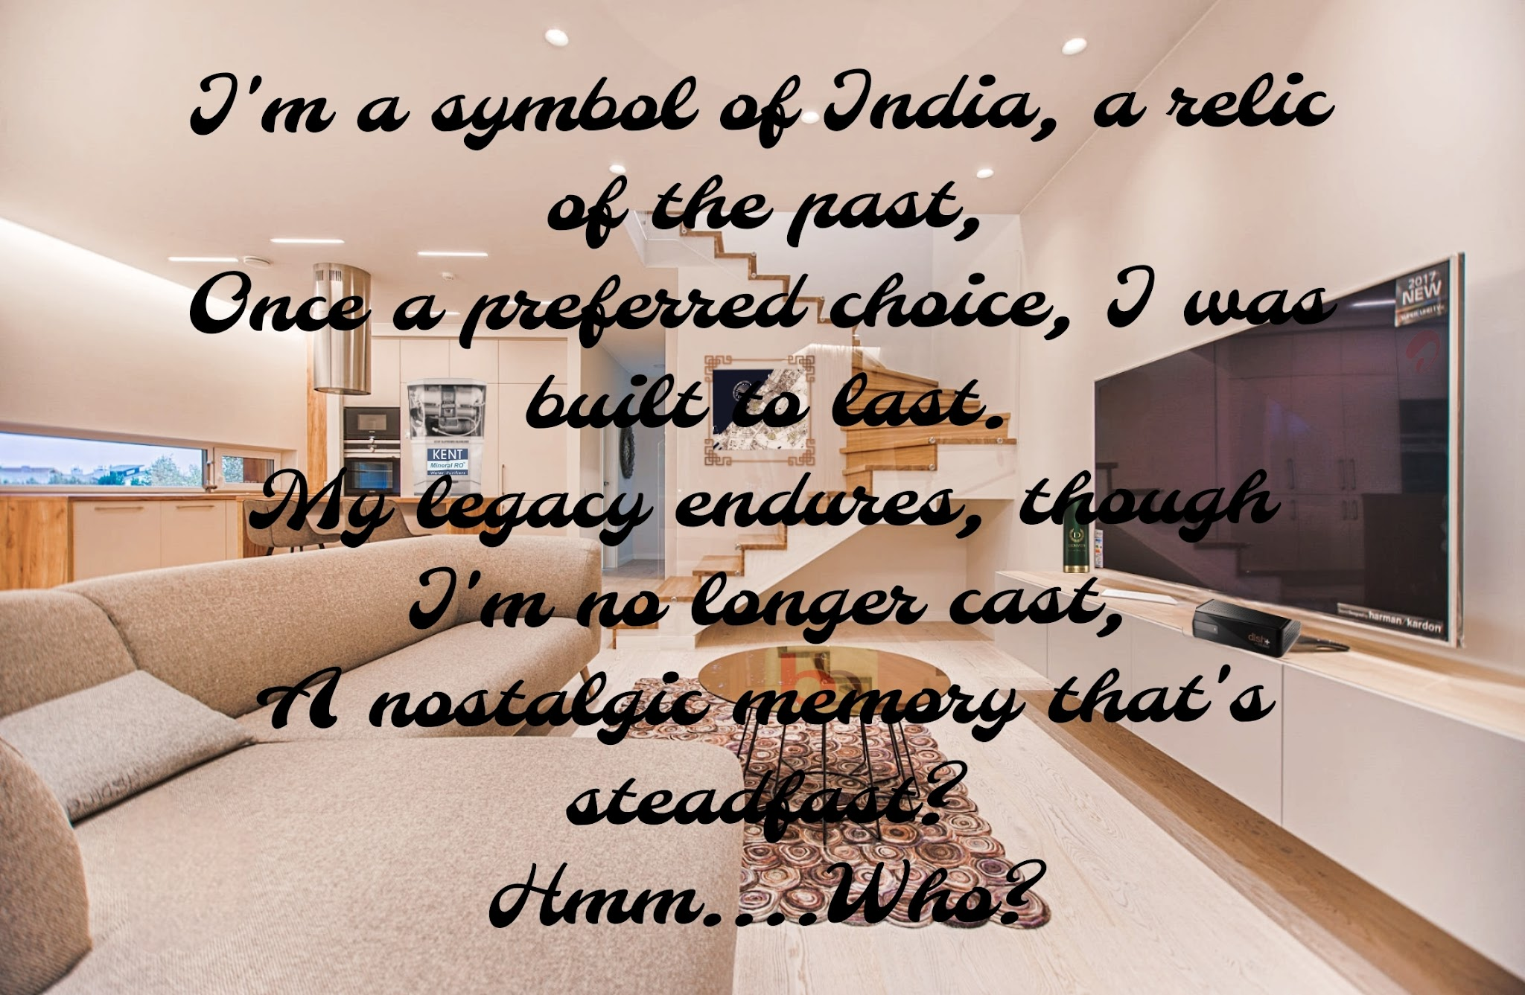
Hints: There are many brands hidden in the image.

- Dish Tv setup box below the TV
- Kent RO on the wall in the kitchen
- Dubai map on the centre wall
- Feint Big Basket logo on the table

The text riddles answer is Ambassador C, KentRo, Dubai Tourism, BigBasket, Hyundai) share in common? Their brand ambassador.
Answer: Shahrukh Khan
Q Hint: ककककक

R1 Question 5:

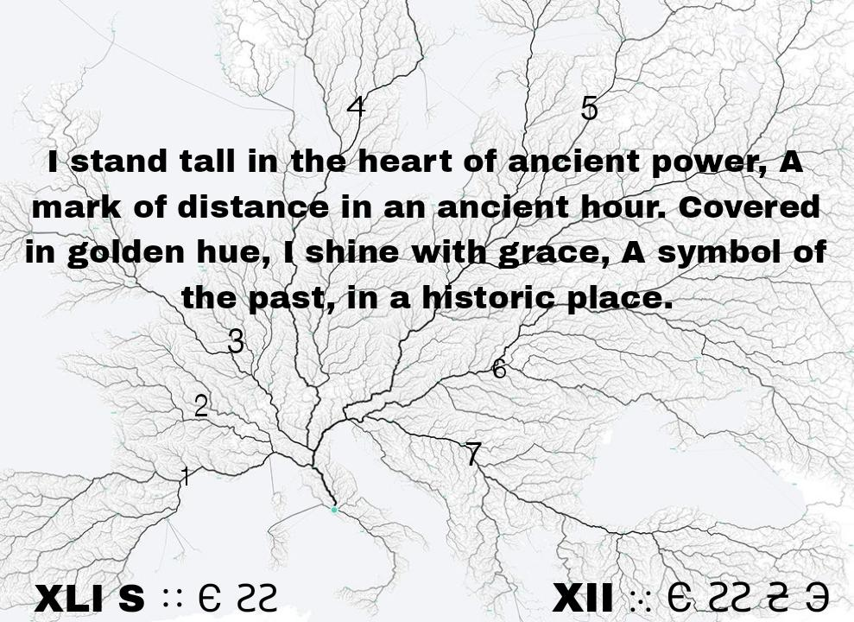
Hints:
- The image behind depicts a geography and symbolizes a famous proverb 'All roads leads to Rome'
- Looking into the history of the proverb it originates from a monument in Rome.
- As there are many monuments in Rome. The riddle suggests a specific monument. -The golden milestone.
- Given below are the coordinates of Rome in Roman Numerals.
The golden milestone is also known as
Answer: Milliarium Aureum

**Let Bygones be Bygones Question 6
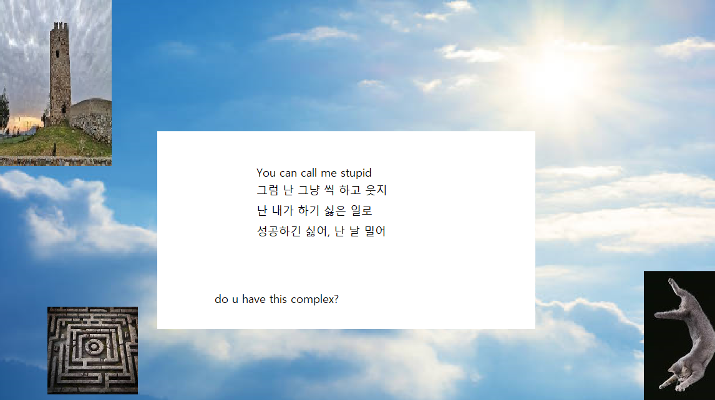
Link of cat falling maybe added.
Answer: icarus
Hint: the pic on top right is the maze where icarus’s father trapped minnataur. The tower is their prison. The pic is a relief.

The text upon googling reveals the lyrics of a song called wings, which starts with “take me to the sky”. The complex being icarus complex. The clouds and sun being further refrences

The falling cat signifying the incident and icarus’s curiosity.

Remark:- Change Icarus picture

R0 Question 7:

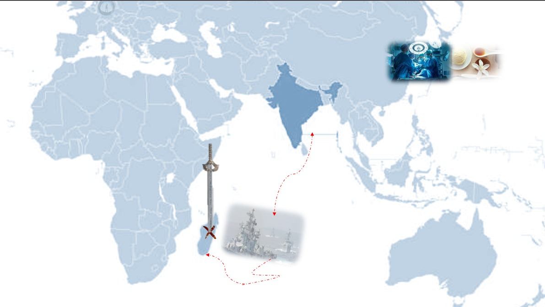
Bg is the world map. Pic of animals. Top right operation vanilla (Navy operation) Logo of dreamworks on left.

Updating Options:-
- Diana
- Cyclone Diane

Answer: Diana

**On Hold — Question 8: (remark, Nagesh:- question is pretty easy to Google just from text )

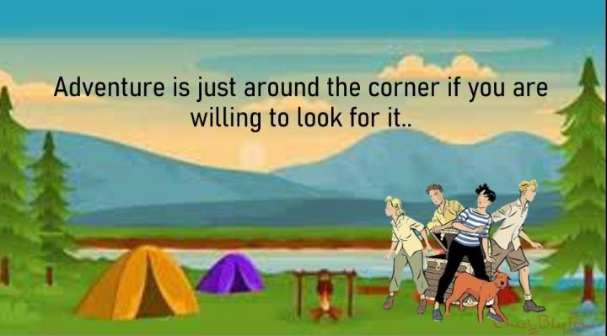

Bg suggests adventure.
Signature on the right corner suggests Enid Blyton. There are 4 friends n a dog. The quote from the same series.

Answer: Famous Five

R1 Question 9

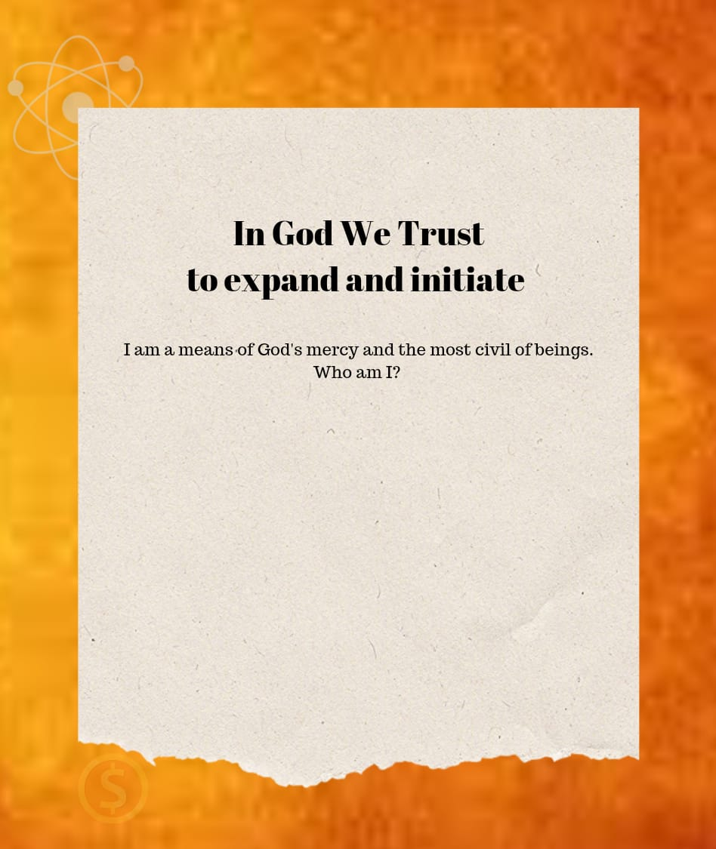

Answer- Georges Lemaitre
Georges gave the Big Bang Theory.He was ordained a priest aka means of God’s mercy.He took up Civil Engineering. Penny in the show The Big Bang Theory is depicted by the dollar coin on the bottom left corner and the phrase “In God We Trust”. To expand and initiate is a direct reference to the Big Bang Theory.

Remark:- Add Infinite QR

R1 Question 10
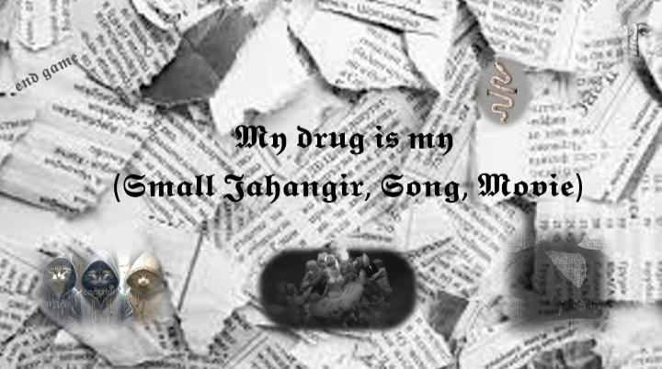

My drug is my (baby). Line of a song of the album. Bottom right pic indicates Taylor Swift. Top right album cover photo blurred. Bg also suggests cover bg. End game another song in the album. Snake ring: the main prop used in the album. The bottom poctures are for the swifties. First suggests the cat gang.. a scene in music video. The second suggests theme of the album. Again a scene in the music video. Also the font is same as that on album cover.

Answer: Reputation

Remarks :- Image Resolution

**On Hold — Need Work — Ques 11(hints are vague )

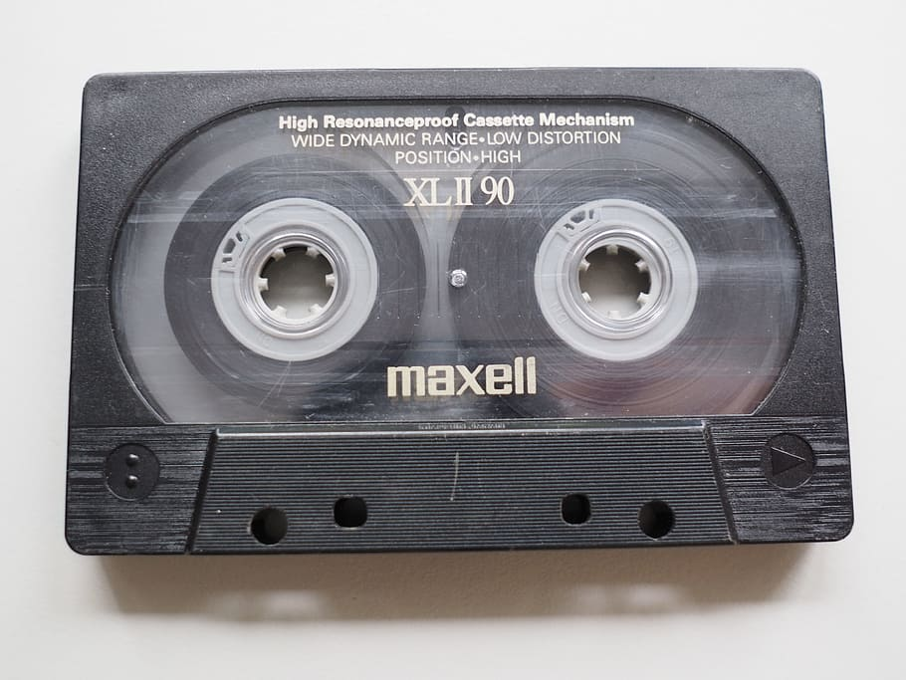

Never imagined 'nrita'can be train
Jumbled letter can be confusing
And only one combination is correct
Gets more perplexed
When played with sentences
Once the game is over,
Thrill is over.

Answer: the conjuring 2
There was a train scene in this movie where they combine two casettes to know what bill willikins wanted to say(this was a sort of jumbled sentences)which when combined in correct order solved the mystery of demon.

Updation:-
- Radio w/ 2 cassettes
- QR to jumpscare
- Overlapping Audio Channels

R1 Question 12

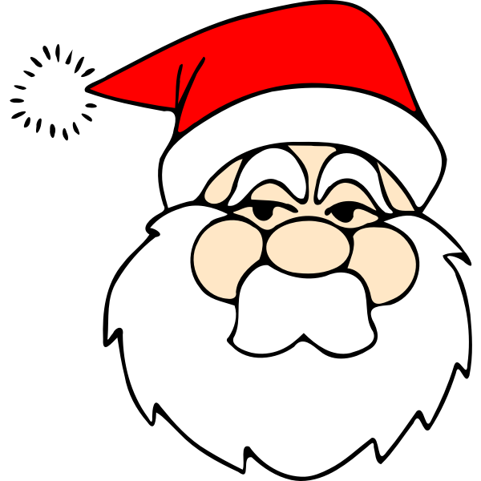
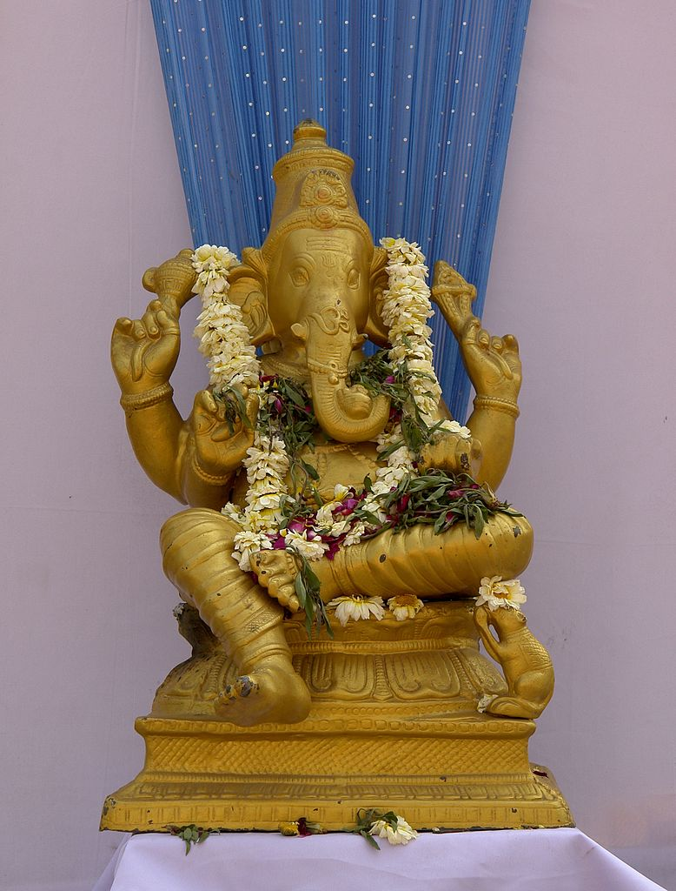

I am not Santa Claus
Though thou can't ignore me
Jail has been broken
And I am free

Who I am:
In my honour
Bronze was melted down
Thanks to roy

Remember i and Santa
Have something common
But not identical.

Answer: red phrygian cap
Here I -labour who were enslaved before French revolution. After breaking Bastille prison,labour wore a red phyrigian cap which is common to Santa Claus and him. D.P.roy Chaudhary had made bronze sculpture (triumph of labour)to pay homage towards them in 1959.sculpture of Ganesha depicts that roy had made a sculpture regarding bronze.

**On Hold — Q13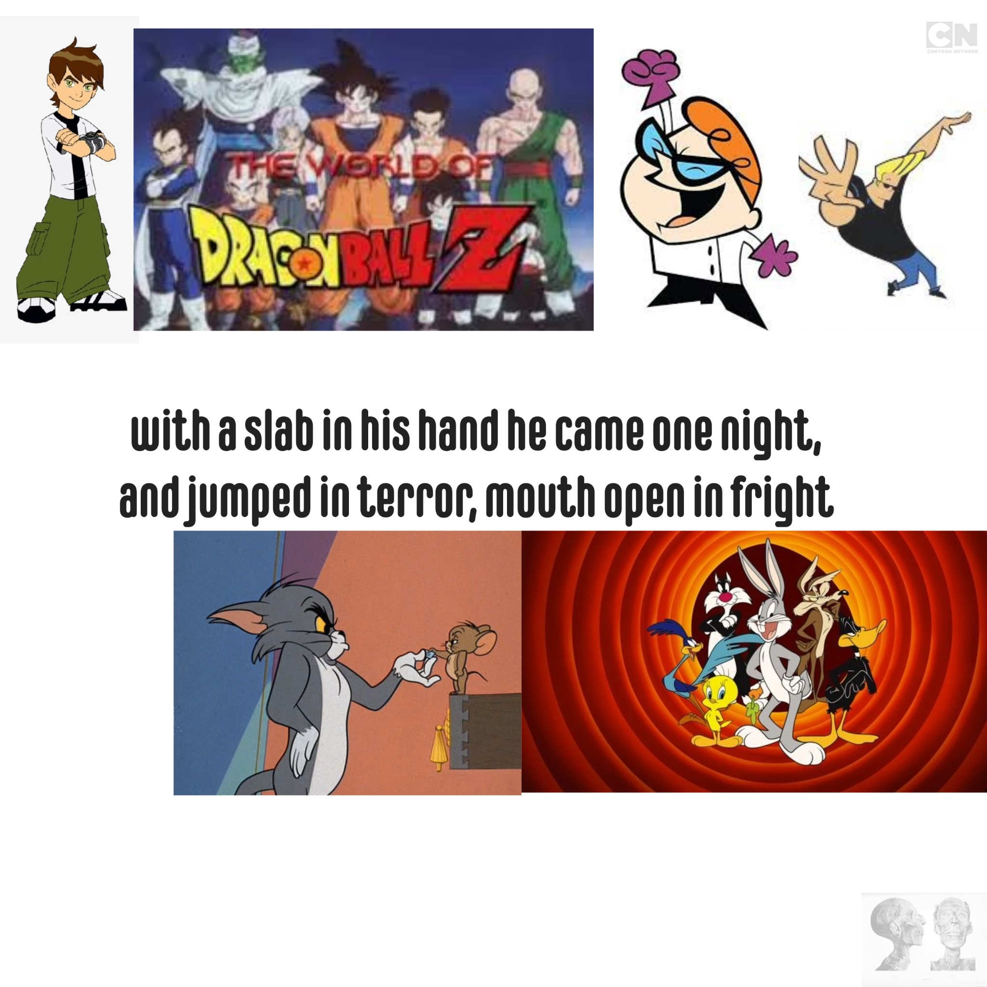

ANSWER:
2000. the images show different cartoon shows being aired on cartoon network during 2000. The images may indicate toward the most famous cartoon show aired on cn, courage(the only cartoon that has not been shown here). Courage, the cowardly dog show, had aired its best horror episode “the king ramses’s curse” in 2000. The image down right shows image of a mummy of king ramses.

**Nope R0 Question 14
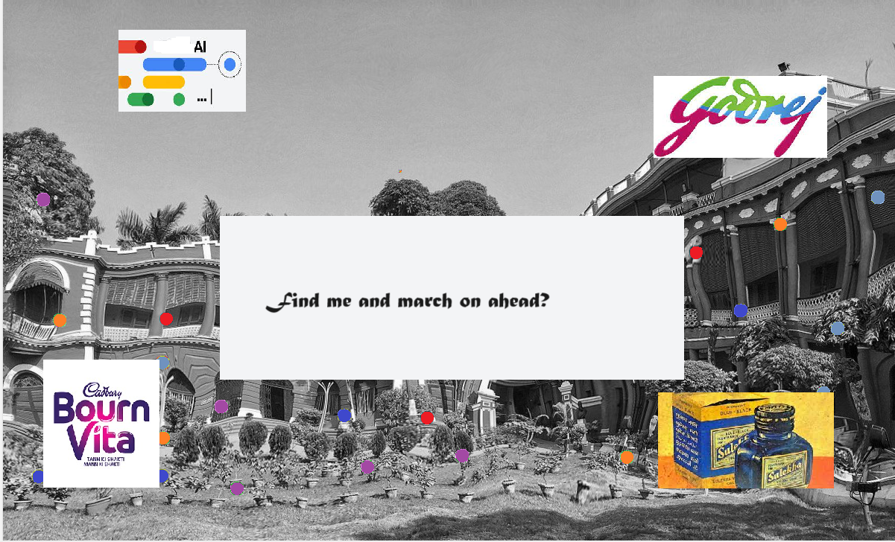
Answer: rabindranath tagore
Hints: the house in the background being his residence, jorasanko thakurbari. The symbol on top left being google bard, tagore was called bard of bengal. The three brands being the brands for which tagore did ads for in order to promote domestic production.”

The logos can be in hidden links too

R0 Question 15:
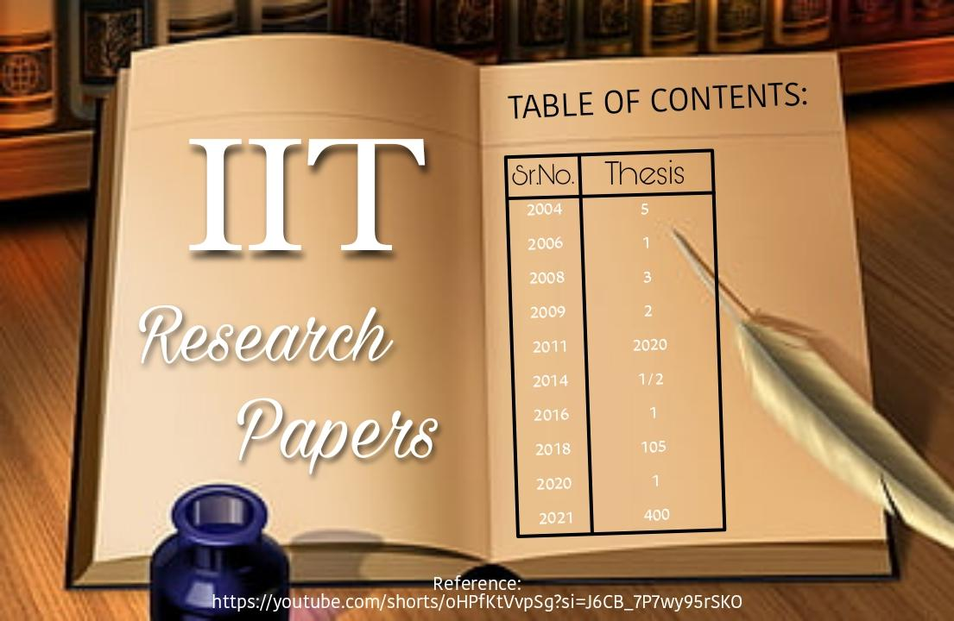
Answer: Chetan Bhagat - Book Titles - Youtube Link(3-Idiots)
https://youtu.be/iFkoP8y9648?si=hgZM0g0Mur5wIhnX
troll link
https://youtube.com/shorts/PTPsi4avoj0?si=ZzbrVG2e_Vj3zhjK

R1 Question 16
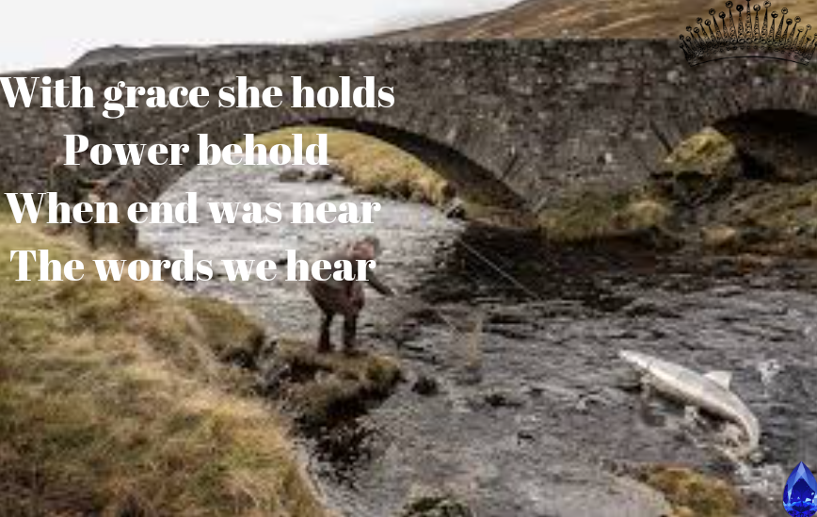

Answer: xaviergourmelon

R0 Question 17
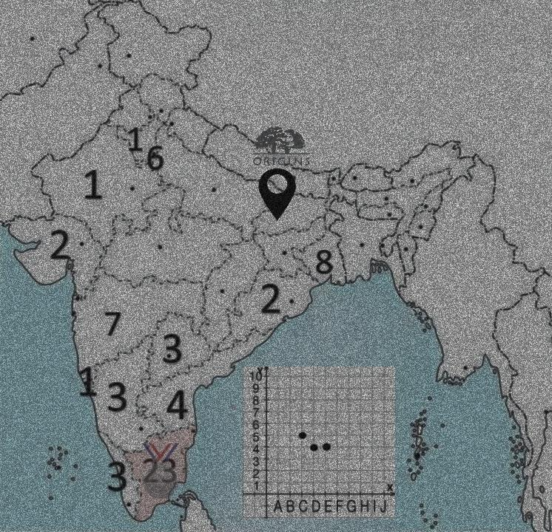
The above map of India has some numbers. These represent the number of grandmasters in Chess from each state.
Hints:
- Highlighted Tamil Nadu and also a silver medal on it. In 2023 Prag Bagged silver medal.. second to Magnus.
- There is a coordinate system which has points D4 C5 E4 marked go on it. Which shows chess moves played between Pragg and Magnus in the World Cup.
- The state of Patliputra has also been marked. With a logo of origins. It is believed that chess originated in Gupta Dynasty Patliputra originally known as Chaturanga.

Answer: Praggnanandhaa
Hint: v=cIMM0-HyDH8

R1 Question 18
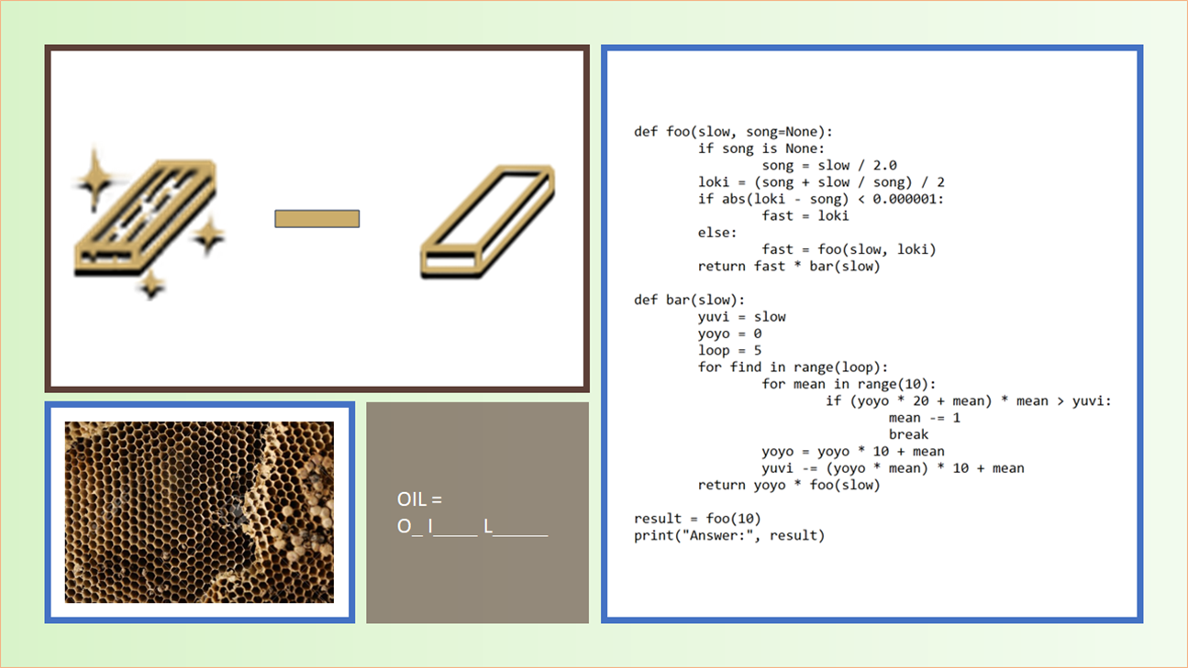
Scientists recently on 4th Sept stated a theory (while working on an Egyptian mummy). They theorized how eternity would smell like.
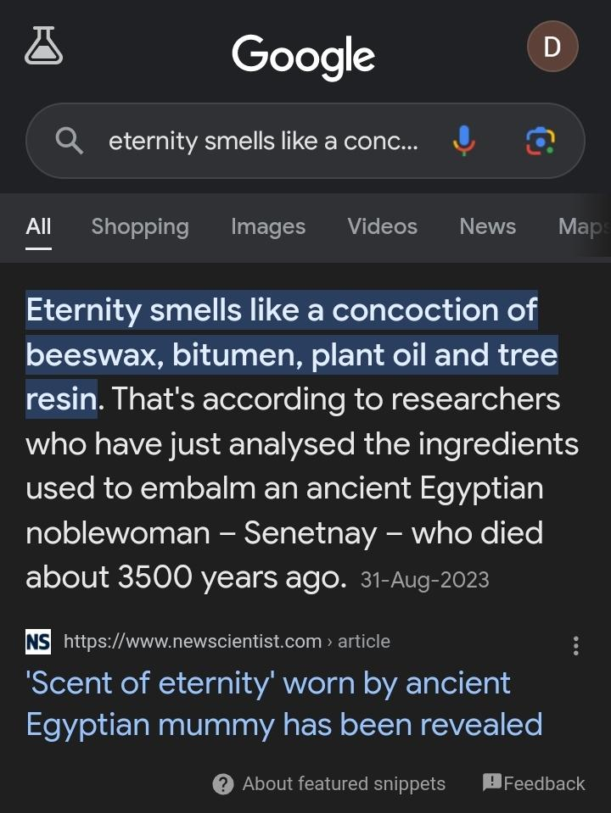

Text: Discovering Tut’s
Hint: 4: taste, 2: swirl, 1: color, 5: savor, 0: combine
Answer: senetnay

R0 Question 19:
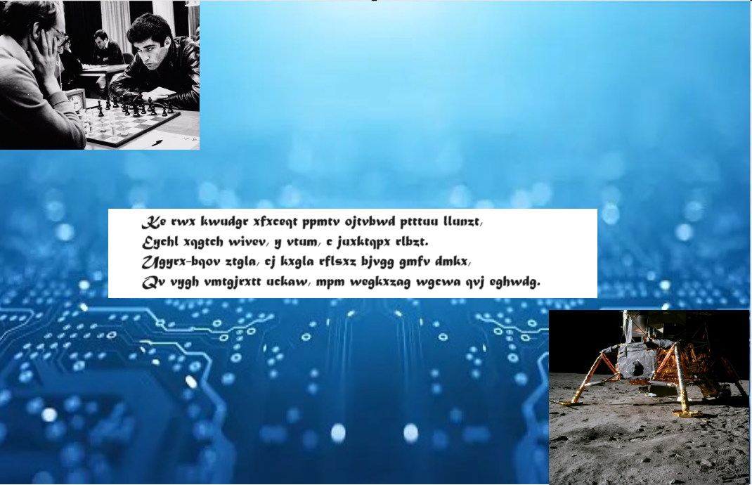

Answer:IBM

The computer background gives a field of search. Caesar salad points to caesar cipher used to decode the text given. IBM’s deep blue defeated gary kasparov, the first time a computer defeated human and moon landing computers had huge help from IBM

R0 Question 20:
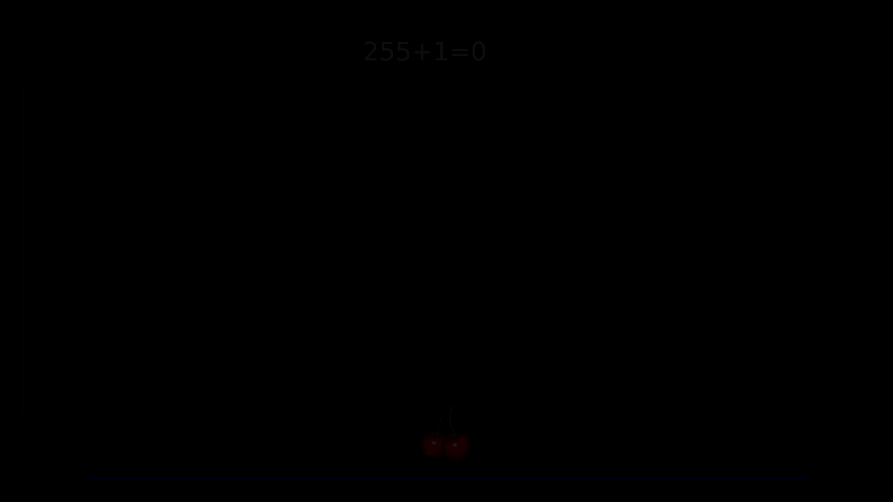
Answer: Pac-Man
Hints:
- `255+1=0` is written near the top middle. This is a reference to the 8 bit integer overflow that occurs in Pac-Man.
- A cherry is present near the bottom middle, in reference to the pac-man powerup.
- There is a very faint rounded blue border in the image. Black and blue are the colors of the background and the walls in pac-man.

R2 Question 21:
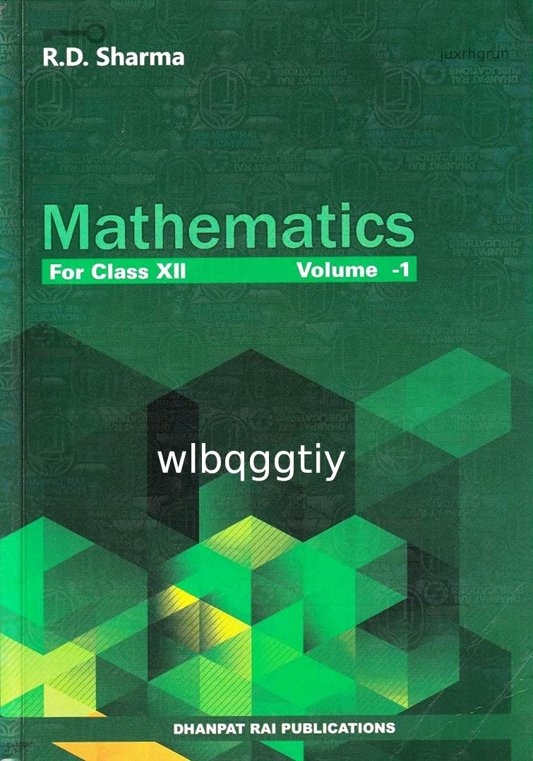
Answer: The Hobbit
Hints:
- There is a picture of a key above the author’s name. The key for the first part is “rd sharma”.
- We use the mapping a->0, b->1… z->25, “ ”->26 (the whitespace character maps to 26)
- There is the string “juxrhgrun” near the top right. Subtracting “rd sharma” from “juxrhgrun” (mod 27), we get “try again”. This is the key for the second part.
- Subtracting “try again” from “wlbqggtiy” (mod 27), we get “E3.
- Almost all of the names of the dwarves in The Hobbit, as well as Gandalf’s, are taken from a section of the Völuspá called the Dvergatal (the "Catalogue of Dwarves").

How the subtraction works
- “juxrhgrun” becomes [9, 20, 23, 17, 7, 6, 17, 20, 13] using our mapping.
- “rd sharma” becomes [17, 3, 26, 18, 7, 0, 17, 12, 0]
- Subtracting “rd sharma” from “juxrhgrun”, we get [-8, 17, -3, -1, 0, 6, 0, 8, 13]
- Now we mod 27 all the numbers to get [19, 17, 24, 26, 0, 6, 0, 8, 13]
- This corresponds to the string “try again”

R0 Question 22:

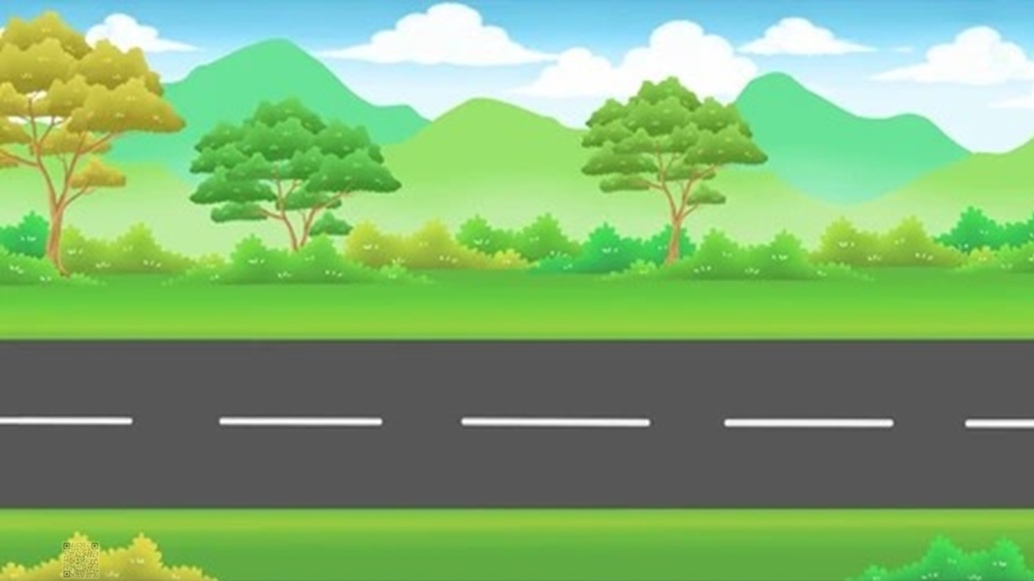
Amidst stars' dance, celestial delight,
Nebulas swirl in the vast night,
Dreams of galaxies, infinite flight,
Revealing secrets, a cosmic sight,
Ethereal beauty, shimmering bright,
Astronomy's wonders, a wondrous height,
Suspended in space, a breathtaking invite.

Answer: Doppler Effect

